------------------- *Hoofdkantoor API Guide* -------------------

This is the user guide for our Hoofdkantoor API.

Here you’ll find all information needed to use it. If after reading through this guide, you still have trouble using our API. Feel free to contact any of the developers:

Pepijn Bullens (2WDV1),

Noah Kamphuisen (2WDV2),

Nick van Zelm (2WDV2).

*movie-data-call: -----------------------*

**- what does it do:**

The movie-data-call is a huge part of our Hoofdkantoor API. When called you receive important data about all movies, or a specific movie. This includes:

* Id
* Title
* Description
* Image
* Rating
* Genre
* Length
* Release Date
* Directors (with images)
* Actors (with images)
* Viewing Guides (with images)
* Link to the movie trailer

**- when do you use it:**

This call is used when displaying movie data. **Important**: don’t use this api call when trying to get movie play dates and or available places in the playing movies. For this use our *‘location-movie-data-call’*.

**- how does it work:**

An API call can be done in a lot of ways. One of the simplest ways is with a Javascript Fetch. Example:

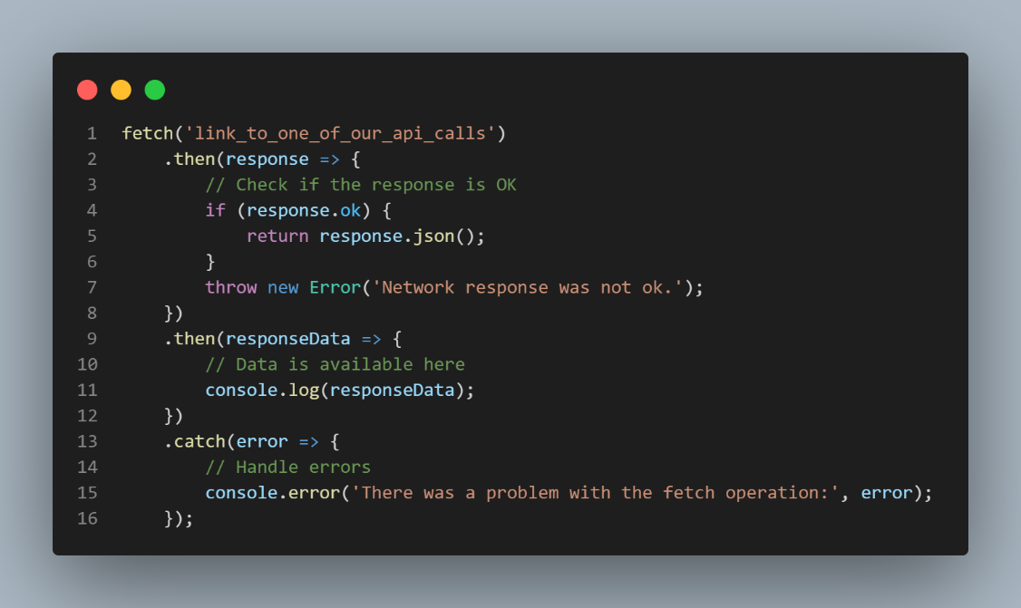

An API call also be given parameters. Here is an example for getting a movie with the id of 1:

* https://link _to_one_of_our_api_calls.com/1

**- parameters (optional):**

* movie id = {int} *- what movie*

*location-movie-data-call: -----------------------*

**- what does it do:**

The location-movie-data-call is also important in our API. When called you receive data about all movies playing in the near future, or you can specify the movie id/location id. The data received includes:

* Id
* Location (id, name)
* Play time
* Plays this week (true/false)
* Plays today (true/false)
* Place data (includes all occupied and available places to sit)

**- when do you use it:**

Use when displaying the movies that will be playing in the near future. Also take advantage of the *‘plays this week/today’*, booleans. For example, in the filtering of the movie agenda. **Important**: This call can be used in combination with our *‘movie-data-call’*. For example, use the id obtained from the *‘location-movie-data-call’*, and use it to call the extra data from the *‘movie-data-call’*.

**- how does it work:**

This API call can also be given parameters. Here is an example for getting a movie with the id of 1 that is playing in a location with id 2:

* https://link _to_one_of_our_api_calls.com/1/2

You can leave one of the parameters as *null* if you want to accept any of that type.

Example:

* https://link _to_one_of_our_api_calls.com/1/null

**- parameters (optional):**

* movie id = {int} *- what movie*
* location id = {int} *- what location*

*reserve-place-call: -----------------------*

**- what does it do:**

The reserve-place-call was made for each movie establishment managed by us. With this API call you can reserve a seating place. In return you get a message containing the status of your reservation.

The following messages exist:

* place does not exist
* *- the place you’re trying to reserve doesn’t exist*
* no places available
* *- all places are taken*
* failed to reserve place
* *- something went wrong in updating our database*
* place already reserved
* *- place is already reserved*
* no place data found
* *- no data found*
* invalid GET parameters
* *– you inserted incorrect data in the GET parameters*
* required GET parameters are not set
* *– no GET parameters given*
* place reserved successfully
* *– successfully reserved your place*

**- when do you use it:**

Use when trying to reserve a seating place for a specific movie in a specific location.

**- how does it work:**

This API call can also be given parameters. Here is an example for reserving a place for the movie with id 1 in the location with the id 2 in place 5:

* https://link _to_one_of_our_api_calls.com/1/2/5

You **cannot** leave one of the parameters as *null.*

**- parameters:**

* movie id = {int} *- what movie*
* location id = {int} *- what location*
* *place id = {int} - what place*